DRC-03: Applicability and Procedure to pay Additional Tax
This article covers the circumstances under which the payment in form DRC-03 is required to be filed along with the time limits. Also, learn the steps on how to file the same on the government GST portal in detail.
The article covers the following:
- What is form DRC-03?
- When should a taxpayer make a payment in DRC-03?
- Prerequisites before filing DRC-03
- Steps to file DRC-03
- Where to report cash payments in GST returns?

What is form DRC-03?
DRC-03 is a payment form in which a taxpayer can pay the tax by raising its liability voluntarily or in response to the show cause notice (SCN) raised by the Department. Below is the format of Form DRC-03:

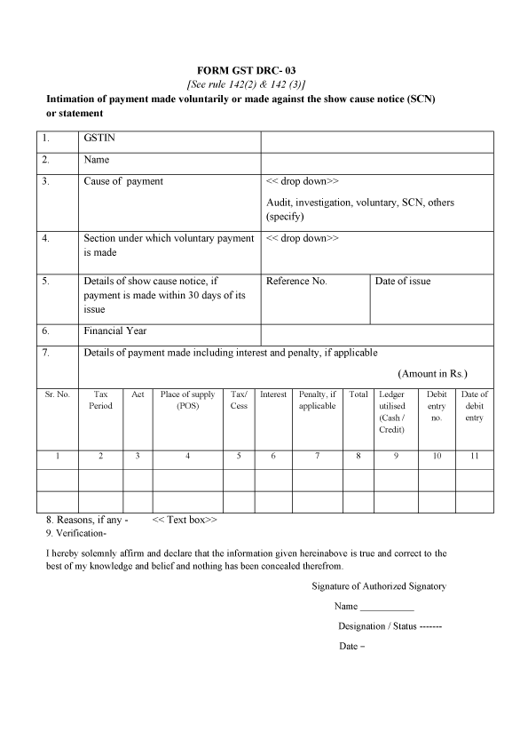

When should a taxpayer make a payment in DRC-03?
Form DRC-03 is filed for making a voluntary payment of outstanding liabilities u/s 73 and 74 of the CGST Act. A taxpayer can self ascertain the tax before issuance of SCN or within 30 days of SCN determination to avoid the hassles of demand and recovery provisions.
Section 73 – deals with cases where there is non-payment/under-payment of tax without any intention or invocation of fraud.
Section 74 – deals with cases where there is non-payment/under-payment of tax with intention or invocation of fraud.
Point to note: All the payments need to be made either from input tax credit available in electronic credit ledger or cash balance available in the electronic cash ledger. But, in case of interest and penalties ITC utilisation is not available. It has to be compulsorily paid in cash.

Prerequisites before filing DRC-03
Form DRC-03 is used for making a voluntary payment of tax. Voluntary payment can be made either:
- Before the issuance of show cause notice;
- Within 30 days of issue of SCN, in case the show cause notice is already issued

Steps to file DRC-03
Step I: Login and navigate to User Services
Login to GST Portal and go to ‘My Applications’ under ‘User Services’.
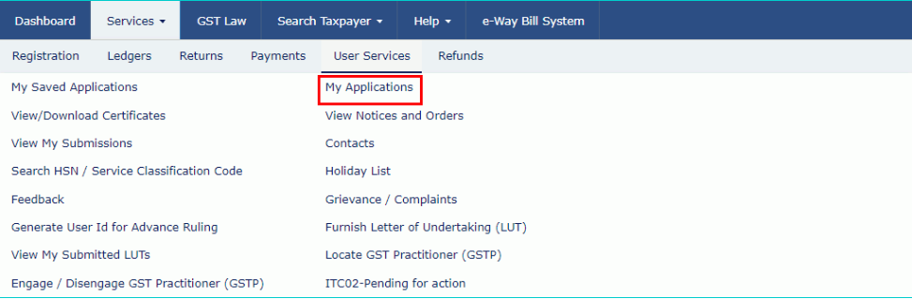

Step II: Choose either of the 3 circumstances under which a taxpayer makes payment:
Case 1: A taxpayer has not made any payment and does not have a payment Reference Number (PRN).
Case 2: A taxpayer has generated PRN but is unutilized and comes for payment within 30 minutes of generation of PRN.
Case 3: A taxpayer has generated PRN and is unutilized and the taxpayer comes for payment after 30 minutes of generation of PRN.

Steps to be performed for Case 1:
Step (a) Select the Application Type as ‘Intimation of Voluntary Payment – DRC-03’ and then click ‘New Application.’
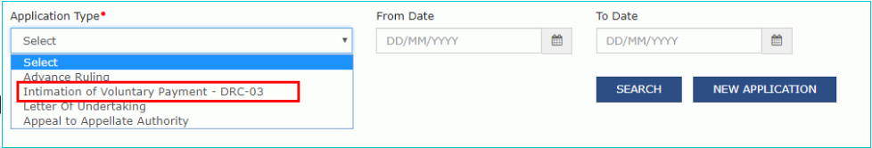
Step (b) A taxpayer will get 2 options whether payment is made Voluntary or against SCN:
1. Voluntary payment: Payment date will be auto-populated without an option to edit.
2. Payment against SCN: A taxpayer has to manually enter SCN Number and select the issue date which must be within 30 days of making payment.
Note: Application for intimation of voluntary payment can be saved at any stage of completion for a maximum time period of 15 days. If the same is not filed within 15 days, the saved draft will be purged from the GST database. To view your saved application, navigate to Services > User Services > My Saved Applications option.
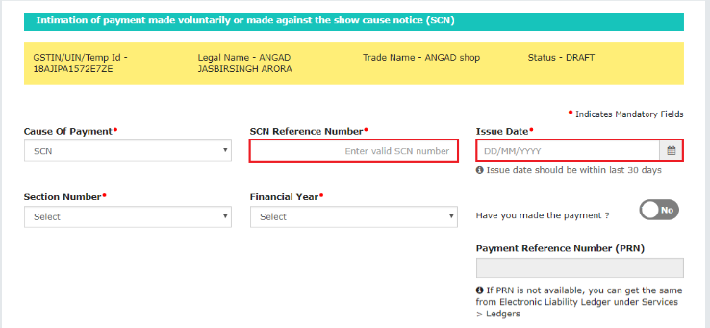

Step (c) Select the Section under which payment is being made, the Financial Year and then select the from date and to date of the overall tax period.

Step (d) Provide details of payment including interest and penalty. A taxpayer can provide additional details by clicking on ‘Add’. Then, click ‘Proceed To Pay’.
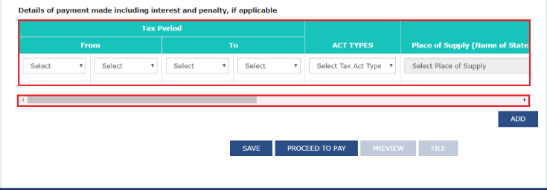

Step (e) Voluntary payment page will be displayed which will be divided into 3 sections:
-Liability Details: Liabilities are displayed in this table.
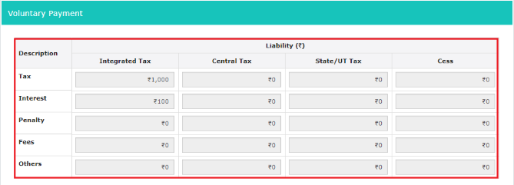

-Cash Ledger balance: The cash balance available as on a particular date is reflected in this table. The taxpayer has to enter the value of cash to be paid from the available balance against outstanding liabilities.
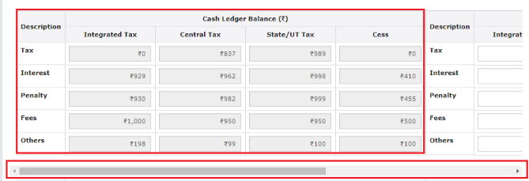

-Credit Ledger balance: ITC available as on date is reflected in this table. The taxpayer has to enter the value of liability to be paid through ITC and click Set Off.
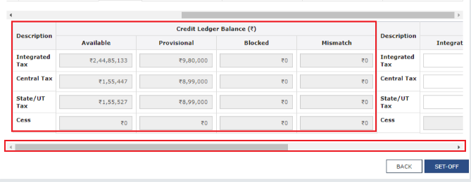

Step (f) A confirmation message will pop up stating the cash and ITC balance being used up for making payment. On clicking ‘Ok’, a PRN will be generated along with a successful payment message.
Note: If PRN is not available, it can be extracted from the ‘Electronic Liability Register’ under Services>Ledgers>Electronic Liability Register.
Step (g) To view the draft DRC-03, Click the ‘Preview’ button on the page-‘Intimation of payment made voluntarily or against SCN’.
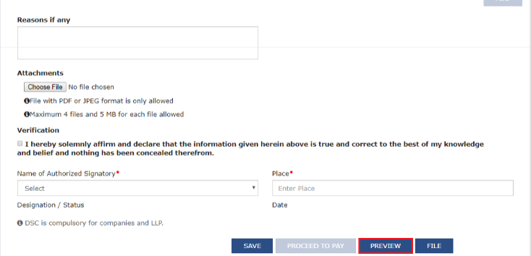

Step (h) Provide reasons if any, in the field provided. Choose a file in the attachments section to upload. Click on the verification checkbox and then select the ‘Authorised Signatory’ and enter the ‘Place’.
Step (i) Click on ‘File’. Two options will be available:
- File with DSC: Browse the certificate and click on the button ‘sign’.
- File with EVC: An OTP will be sent to the registered mobile number and email ID. On validation of OTP, a success message will be received along with ARN.

Steps to be performed for Case 2:
Step (a) Follow the steps as mentioned in Case 1 till the taxpayer reaches on Intimation of payment made voluntarily or against the SCN page.

Step (b) Select ‘Yes’ for the option – Have you made payment? and enter the PRN.
Step (c) A link, known as ‘Get payment details’ will be displayed. Once the taxpayer clicks on it, details will be auto-populated on the basis of the respective payment that was made.
Step (d) Click on ‘Preview’ to view draft DRC-03 and then follow the same steps to file the application as mentioned in Case 1.
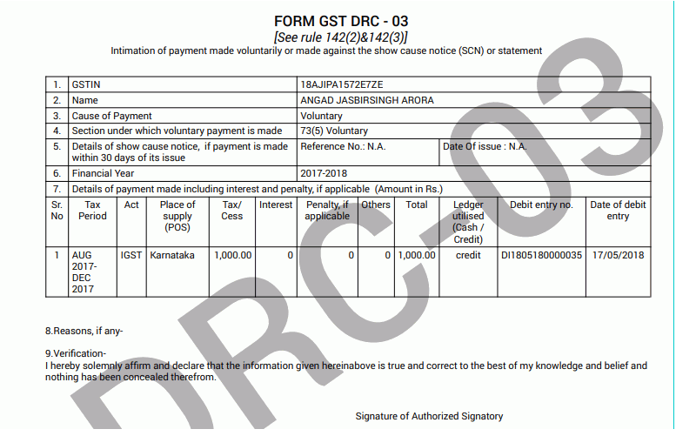

Steps to be performed for Case 3:
Step (a) Follow the steps as mentioned in Case 1 till the taxpayer reaches on Intimation of payment made voluntarily or against the SCN page.
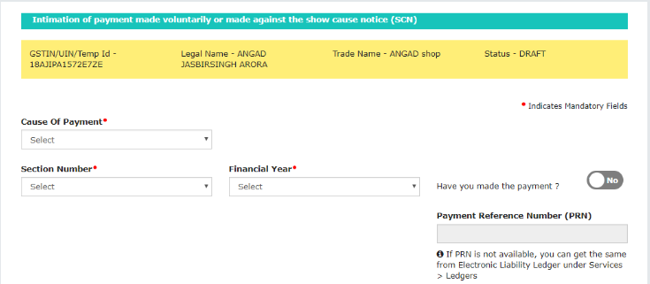

Step (b) Select Yes for the option – Have you made payment? and enter the PRN.
Step (c) A link, known as ‘Get payment details’ will be displayed. Click on the link and enter the details, since the details will not be auto-populated as mentioned in Case 2. This happens because the time limit of 30 minutes has passed.
Note: The processing will happen in the Back end, wherein the system will check whether the amount entered by taxpayer matches with the payment made. If yes, the intimation form will be accepted. If no, an error message will pop up.
Step (d) Hereafter, follow the same steps as mentioned in Case 1 for filing the application DRC-03.
Note: With respect to Case 2 and Case 3 if the PRN is already utilized, an error message will be displayed asking the taxpayer to enter the unutilized PRN.

Where to report cash payments in GST returns?
Cash Payments in various GST returns are reflected in the below manner:

GST Return/Application | Electronic Cash Ledger
GSTR-3B(Monthly Return) | Electronic cash ledger is an e-wallet. All payments made in  cash/bank are reflected in this ledger. A taxpayer can first utilize his  balance in ITC to pay tax liabilities. If the liabilities are greater  than the balance in ITC, the same has to be paid in cash.
GSTR-9 (Annually) | Any balance tax liability if not paid while filing GSTR-3B needs to be  paid while filing GSTR-9. Available balance in electronic cash  ledger is used to make payment of outstanding liabilities. In case,  the liabilities are higher than the available cash balance,  a challan has to be created for making additional cash payment.
In case of demand notices | In case of demand notice, payment can be made by utilizing ITC  and balance cash available in the Cash Ledger. The remaining  liability needs to be paid in cash by creating additional cash challan.  Interest and Penalty need to be compulsorily paid in cash.  A proper officer will issue acknowledgement in Form DRC-04  regarding the payment made in Form DRC-03 and the  proceedings will be concluded by the Officer by issuing  an order in Form DRC-05.

